**INHERITANCE**

**Super Keyword**

* Keyword ***super*** is similar to this:-



**Aggregation**

* Creating a variable in an object of another object type is called **aggregation (has-a-relation)**.

**Types Of Inheritance**

* Single level inheritance
* Multi-level inheritance
* Hierarchical inheritance
* Multiple inheritance (**\*not** supported by Java)
* Constructors are **not** inherited in Java.

**Overriding Of Methods**

* The **return type** and **parameter list** however must be the same.
* Also known as **runtime polymorphism**.

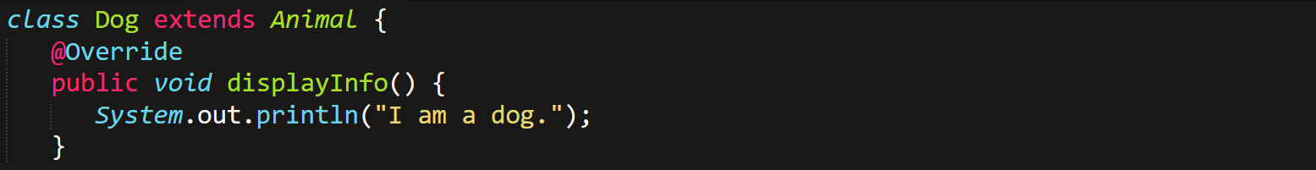

* **final** and **static** methods **can’t** be overridden.
* To access superclass’s method, we use ***super*** keyword.
* The access modifier of overridden method in subclass must provide **higher** access.

**Abstract Classes**

* We **can’t** create objects of abstract classes.
* There can be abstract class, and also abstract methods.
* Abstract class can also contain regular methods.



* ***super()*** is used to access the constructor of superclass, abstracted one.

**Final Keyword**

* The ***final*** keyword in Java is used to define constants, like **const** in C,C++ & C#.
* Final method **can’t** be overridden.
* Final class **can’t** be inherited by other classes.